St. Joseph’s Church, O’Connell Avenue, Limerick
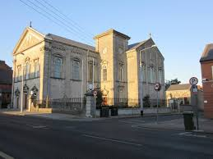
Church Notices 27th February 2022

Sun 27th February 10.30am – Tommy Gaynor (Birthday Remembrance)
10.30am – Aidan Twomey (7th Av)
12.30pm –Madeline Power (4th Av)
12.30pm – Cyril Frawley (11th Av)
12.30pm –Christy Lowe (26th Av)
5.30pm – Mary Hughes (7th Av)
5.30pm – Sonny & Molly Broderick & their Parents
5.30pm – Anthony (Tony) Hayes (4th Av) & William Curtin (43rd Av)
Mon 28th February 10.30am – John Mullins (Av)
Tues 1st March (Shrove Tuesday) 10.30am – Pro Populo
Wed 2nd March (Ash Wednesday) 10.30am – Intention of Clergy
Thurs 3rd March 10.30am – Intention of Clergy
Fri 4th March 10.30am – Intention of Clergy
Sat 5th March 10.30am – Hanora Graham (14th Av)
Sun 6th March 10.30am – Michael Noonan & Deceased Members of the Noonan Family
10.30am – Nellie Mooney
10.30am – Tom Kelly (14th Av)
10.30am – Joe Roche (5th Av)
12.30pm –Joan Berkery (22nd Av), Joe Byrne (23rd Av) & Rita O’Shea (2nd Av)
5.30pm – Denis Bugler (6th Av)

RECENTLY DECEASED
As a Parish Community, we offer our deepest sympathy to the family of Claire Anderson nee Meade formerly of Clancy Strand, Limerick. Claire’s funeral took place on Thursday last. The death has occurred of Robert (Bob) Richardson late of Lynwood Park, Ballysimon Road, Limerick. Bob’s funeral took place on Friday last. The death has occurred of Charles (Charlie) Enright late of Athlunkard Nursing home, Westbury and formerly of Donnellan’s Buildings, Rosbrien. Charlie’s funeral will take place on Monday 28th February. May their souls and the souls of all the faithful departed, through the mercy of God, rest in peace. Amen
ADORATION OF THE BLESSED SACRAMENT
Adoration of the Blessed Sacrament will take place on Saturday 5th March in the main body of the Church immediately after the 10.30am Mass. It will conclude at 12 noon. Should a funeral occur on any Saturday, the congregation will be informed and Adoration will be re-schedualed for the followiing Saturday. Thank you

FAIRTRADE FORTNIGHT takes place 21 Feb – 6 Mar 2022. What can you do? LOOK for the Fairtrade logo. When you BUY tea, coffee, cocoa, chocolate etc with this logo you provide a farming family in the developing world with a fair price for their product so they can live with dignity. Fairtrade is not charity. It is about justice. More information on www.fairtrade.ie

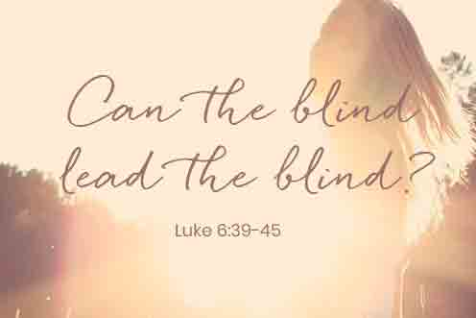

UPCOMING VOCATIONS EVENTS
- Vocations Zoom: Exploring the Priesthood Zoom - March 1, 2021 @ 8pm. For more information, please visit Vocations.ie/zoom
- Theology on Tap: The next Theology on Tap is Tuesday, March 15 @ 8pm. Come out to Bobby Byrnes for presentations by our vocations panel: Father Vincent Stapleton, Seamus and Ellen Hickey, and Sister Mara Rose, O.P.

Pope Francis calls for Ash Wednesday to be Day of Fasting for Peace
During a General Audience address on 23 February last, Pope Francis invited everyone to make Ash Wednesday, next week, a Day of Fasting for Peace in Ukraine.
“My heart aches greatly at the worsening situation in Ukraine. Despite the diplomatic efforts of the last few weeks, increasingly alarming scenarios are opening up. Like me, many people all over the world are feeling anguish and concern. Once again the peace of all is threatened by partisan interests. I would like to appeal to those with political responsibility to examine their consciences seriously before God, who is the God of peace and not of war; who is the Father of all, not just of some, who wants us to be brothers and not enemies. I pray that all the parties involved refrain from any action that would cause even more suffering to the people, destabilising coexistence between nations and bringing international law into disrepute.
And now I would like to appeal to everyone, believers and non-believers alike. Jesus taught us that the diabolical senselessness of violence is answered with God's weapons, with prayer and fasting. I invite everyone to make next 2 March, Ash Wednesday, a Day of Fasting for Peace. I encourage believers in a special way to dedicate themselves intensely to prayer and fasting on that day. May the Queen of Peace preserve the world from the madness of war.” Pope Francis
Contact Details: Fr. Liam Enright 087-7415603, Sacristan: Úna McCarthy 061-313401
Email: stjosephsparishlk@eircom.net Website: stjosephsparish.ie

